|  |  |
| --- | --- |
| Contact Details Narrogin Senior High School | **NARROGIN SENIOR HIGH SCHOOL**  **SCIENCE VALIDATION TASK $\frac{}{35}$**  **Name:** |

Lab worksheet: Oh, What a tangled Web We Weave

Plants use light energy of the sun to make food. The food is stored in the cells of the plant. Plants are called producers because they make food. Some of the stored energy in the food plants make is passed on to the animals that eat the plants. Plant-eating animals are called primary consumers. Animals that eat other animals are called secondary consumers.

The pathway that food/energy takes through an ecosystem is called a food chain. A food chain also shows the movement of energy from plants to plant eaters and then to animal eaters. An example of a food chain can be written:

seeds ➔ sparrow ➔ hawk

Some of the food energy in the seeds moves to the sparrow that eats them. Some of the food energy then moves to the hawk that eats the sparrow. Normally, only about 10% of the energy produced by the "food" moves to the consumer. Most of the other energy is used to keep the organism alive and allow it to reproduce.

Because a hawk eats animals other than sparrows, you could make a food chain for each animal the hawk eats. If all the food chains were connected, the result is a food web. A food web is a group of connected food chains. A food web shows many energy relationships.

# Procedure:

**Part A. Examining Food Chains**

1. Study the food chains listed below.
2. Complete the table on the next page. Checkmark or "X" all the things that each animal listed on the left side eats.

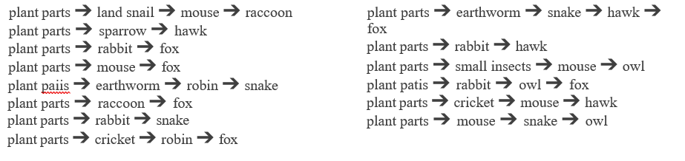

Part B Questions:

1. In how many food chains do the following animals appear? (6 marks)

Hawk _____ Earthworm _______ Fox _____

Owl ______ Snake __________ Small Insects___________

1. In how many food chains do plants (parts) appear? __________ (I mark)
2. List the names of the living things in this forest ecosystem that are producers. (3 marks)
3. List those things that are only primary consumers. (3 marks)
4. What is another name for an animal that is only a primary consumer? (1 mark)
5. List those things that are only secondary consumers. (3 marks)
6. What is another name for an animal that is only a secondary consumer? (1 mark)
7. List the consumers that eat both plants and animals? (5 marks)
8. What is another name for an animal that eats both plants and animals? (1 mark)
9. What would happen to the food web if all the plants were removed?

Explain your answer. (4 marks)

1. Describe how 3 animals might be affected if owls were removed from the food chain.

(3 marks)

1. Draw three food chains showing producers and consumers that you might see in your backyard or on the way to school. (You may use words or drawings)

**End of validation 35 Marks**